DATE …………………….……… STUDENT NO……...……………...…………..…

EXAMINATION CENTRE ……...………………………………………………….…………..

THE SHIPPING AND FORWADING AGENTS’ ASSOCIATION OF ZIMBABWE



## FREIGHT FORWARDING PRACTICE DIPLOMA

**FINAL EXAMINATION**

**PAPER TWO**

# GENERAL PAPER

**29 NOVEMBER 2018**

**TIME ALLOCATION: (3 HOURS)**

**INSTRUCTIONS**

* Answer **FOUR** questions. Question **ONE** is compulsory
* Your student number must appear on all your answer sheets.
* This examination script is the property of SFAAZ and must not be removed from the examination room.
* This paper carries 60% of the final examination marks.
* Answer a new question on a fresh sheet of paper.

**FFP NOVEMBER 2018 Final / P2**

**Section A: CASE STUDY – Compulsory**

**Two haulage trucks caught fire and one of them spilled an unknown amount of sulphuric acid when they were involved in a head-on collision in Dinde area outside Hwange town on Monday night.**

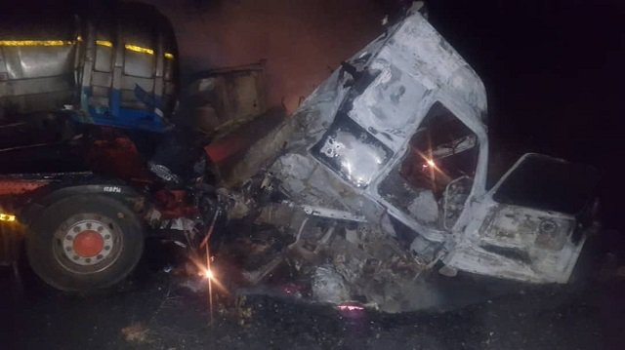A haulage truck that was involved in a head-on collision in Dinde area outside Hwange town on Monday night

The acid tanker was driving towards Hwange while the other one which was going towards Bulawayo was carrying coal and both their hoses were reduced to shells.

Police confirmed the accident which left drivers of both trucks injured while the Environmental Management Agency (EMA) quickly moved in and cordoned off the area to prevent a possible health hazard as the acid can cause harm to humans, wildlife, vegetation as well as aquatic life.

The Officer Commanding Hwange district, Chief Superintendent Newton Mutomba, said investigations are in progress.

“It was a head-on collision after one of the trucks encroached onto the lane of the other and both vehicles caught fire,” said Chief Supt Mutomba.

On approaching a curve at the 305km peg, one of the trucks encroached into the lane of the other resulting in the head-on collision.

**FFP NOVEMBER 2018 Final / P2**

Both trucks caught fire immediately and the drivers, Mr Abdiwahid who is Zambian and Mr Darlington Machadu, a Zimbabwean, were injured in the process, police said.

The drivers were rushed to Hwange Colliery Hospital where they were admitted.

One truck is Zambian registered while the other has a local registration.

Yesterday morning firefighters were still trying to put out the fire from the coal.

EMA officers were collecting acid which was still spilling from the tank. They dug a trench so it could not flow downstream and affect plant life and contaminate water bodies.

EMA Matabeleland North manager, Mrs Chipo Mpofu-Zuze, said precautions were being taken to make sure the acid does not damage the environment.

She said the scene had been cordoned off while all the contaminated soil will be removed.

“The first step will be unhooking the trailer and then digging trenches so that none of the acid will flow away. Then the rehabilitation process will start whereby we will dig up the affected area and take the soil which will be put somewhere where it will be de-toxicated and tested to make sure it’s no longer acidic,” Mrs Mpofu-Zuze said.

She said EMA officers will guard the scene until the rehabilitation process, which will involve bringing in fresh soil from elsewhere, is completed.

Mrs Mpofu-Zuze said said the acid may be dangerous to plant and animals including water life.

Last year, a Zambian registered haulage truck spilt 34 000 litres of sulphuric acid near the same spot after the driver lost control at a curve and the truck landed on its side resulting in the lid of the tank bursting and the contents spilling.

Some villagers reportedly used containers to collect the liquid thinking it was oil. Sulphuric acid can cause severe burns and has adverse health effects.

**The Chronicle**

**FFP NOVEMBER 2018 Final / P2**

**Compulsory Question**

Q1.

1. Identify and explain the convention and protocol that covers the above case and indicate the maximum carrier liability. (6 marks)
2. What are the requirements to the operators, when carrying the above goods that ensure safety and security in this case? (10 marks)
3. Identify and define the type of goods being carried and, using examples, the relevant marks and labels they should bear. (8 marks)
4. Which insurance principles were violated, and how does the law of subrogation work in relation to the incident. (6 marks)
5. Which possible ICT tools would have been installed on both vehicles for driver management? (6 marks)
6. As a forwarder in charge of the sulphuric acid carrying truck, what is your role in the accident? (4 marks)

**FFP NOVEMBER 2018 Final / P2**

**Choose any THREE Questions from the questions below.**

**QUESTION 2**

1. Identify how supply chains compete in terms of time, cost and quality. (8 marks)
2. Show how different supply chains may adopt different and distinctive strategies for competing in the marketplace. (4 marks)
3. How has ICT transformed the freight forwarding business? Use practical examples.

(5 marks)

1. Explain the terms TEU and FEU. (3 marks)

**QUESTION 3**

1. Why is the use of rail transport no longer popular in Zimbabwe, given it is the cheaper than road transport? (6 marks)
2. Using Zimbabwe as a case study, which concept is most appropriate between JIT and JIC as a strategy in logistics? Justify your answer. (6 marks)
3. With reference to attached picture, deconstruct and explain the shown components that make up the rail infrastructure and wagon. (8 marks)

**FFP NOVEMBER 2018 Final / P2**

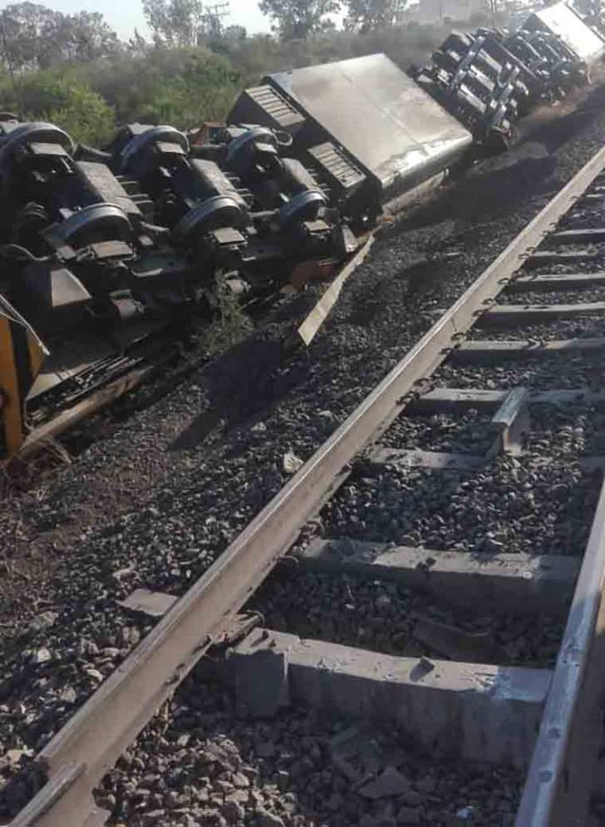

**FFP NOVEMBER 2018 Final / P2**

**QUESTION 4**

1. What critical role does warehouse play in the supply chain management.

(12 marks)

1. Explain how risks or costs can be reduced when working with INCOTERMS from the buyers position.

(4 marks)

1. What is the difference between a freight forwarder and a clearing agent?

(4 marks)

**QUESTION 5**

1. How does Consolidation become a source of revenue to the freight forwarder? Give a practical example using any mode of transport. (10 marks)
2. How important are straits and locks in freight logistics. (6 marks)
3. What is C-TPAT? Briefly explain how it works. (4 marks)

**QUESTION 6**

1. What is the purpose of freight logistics conventions and which particular issues do they seek to address. (12 marks)
2. Explain two factors or instances that indicate that a forwarder is acting as a principle and not as an agent. (4 marks)
3. How do freight forwarders ensure customer satisfaction? (4 marks)